EXPERIMENT 3.1:
INPUT:
#include<iostream>
using namespace std;
//inline function
inline int max(int a,int b){
return (a>b)?a:b;
}
int main(){
cout<<"the max of 10 and 5 : "<<max(10,5)<<"\n";
cout<<"the max of 70 and 60 : "<<max(70,60)<<"\n";
cout<<"the max of 10 and 80 : "<<max(10,80)<<"\n";
cout<<"the max of 0 and 20 : "<<max(0,20)<<"\n";
return 0;
}
OUTPUT:
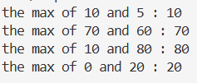

EXPERIMENT 3.2:
INPUT:
#include<iostream>
using namespace std;
int add(int a=0,int b=0,int c=0,int d=0){
int sum=a+b+c+d;
cout<<"the addition of numbers is = "<<sum<<endl;
}
int main(){
add();
add(2,3);
add(2,9,4);
add(5,10,2,3);
return 0;
}
OUTPUT:
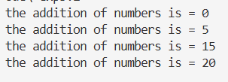

EXPERIMENT 3.3:
INPUT:
#include<iostream>
using namespace std;
int pattern(string ch="*",int count=3){
for(int i=0;i<count;i++){
cout<<ch<<" ";
}
cout<<endl;
}
int main(){
pattern();
pattern("&");
pattern("#",5);
pattern("hello",4);
}

OUTPUT:
